**International University**

School of Electrical Engineering

**Principle of EE1 Laboratory**

**EE052IU**

**[Lab 1]**

**Introduction to Electric Circuit Laboratory**

**Submitted by**

[Đỗ Minh Duy - ITITSB22029]

[Nguyễn Đức Anh - EEACIU23005]

Date Submitted: [28/12/2024]

Date Performed: [18/11/2024]

Lab Section: [1]

Course Instructor: [Nguyen Minh Thien]

**GRADING GUIDELINE FOR LAB REPORT**

|  |  |  |  |  |
| --- | --- | --- | --- | --- |
| **Number** | **Content** |  | **Score** | **Comment** |
| 1 | **Format (max 9%)** | |  |  |
| * Font type | Yes No |  |
| * Font size | Yes No |  |
| * Lab title | Yes No |  |
| * Page number | Yes No |  |
| * Table of contents | Yes No |  |
| * Header/Footer | Yes No |  |
| * List of figures (if exists) | Yes No |  |
| * List of tables (if exists) | Yes No |  |
| * Lab report structure | Yes No |  |
| 2 | **English Grammar and Spelling (max 6%)** | |  |  |
| * Grammar | Yes No |  |
| * Spelling | Yes No |  |
| 3 | **Data and Result Analysis (max 85%)** | |  |  |
| **Total Score** | |  | |  |

Signature:

Date:

**Table of Contents**

List of Figures ........................................................................................….…...........................…. 3

List of Tables .................................................................................................……..........................3

Nomenclature ...........................................................................................................…….………..3

Theoretical Background .............................................................................................…….............4

Objective..........................................................................................................................................5

Introduction.............................................................................................…….................................6

Experimental Procedure.................................................................................................................11

Experimental Results .....................................................................................................................13

Discussion of Results .....................................................................................................................14

**List of Figures**

Figure 1 –………………………….……...………………………………………………………..4

Figure 2 – ………………………………………………………………….……………...……….5

Figure 3 – …………………………………………………………………………………….........7

Figure 4 –………………………………………….……………………….……………...……….8

Figure 5 – …………………………………………………………………………………….......10

Figure 6 – ……………...................................................................................................................12

**List of Tables**

Table 1 – ……………....................................................................................................................11

**Nomenclature**

VDD = DC Voltage Source

Vdd = AC Voltage Source

Iref = Reference Current

**Theoretical Background**

In this section, describe some different resistors:

There are many different types, values, and physical dimensions of resistors. With a power rating of up to one watt, almost all through hole resistors have a series of colored bands that indicate their resistance value, tolerance, and occasionally their temperature coefficient. There can be anywhere from three to six of these bands, but the most popular arrangement is four bands. Following a multiplier band that signifies moving the decimal point to the right or left, the first bands always display numerical values in the resistance. The last bands provide temperature coefficient and tolerance information.

**Figure 1**

**Objective**

In this section, we learn:

1. Lab policies & Lab Safety Rules

2. The use of breadboard.

3. Resistor color codes and capacitor codes.

4. The equipment will be used during this laboratory

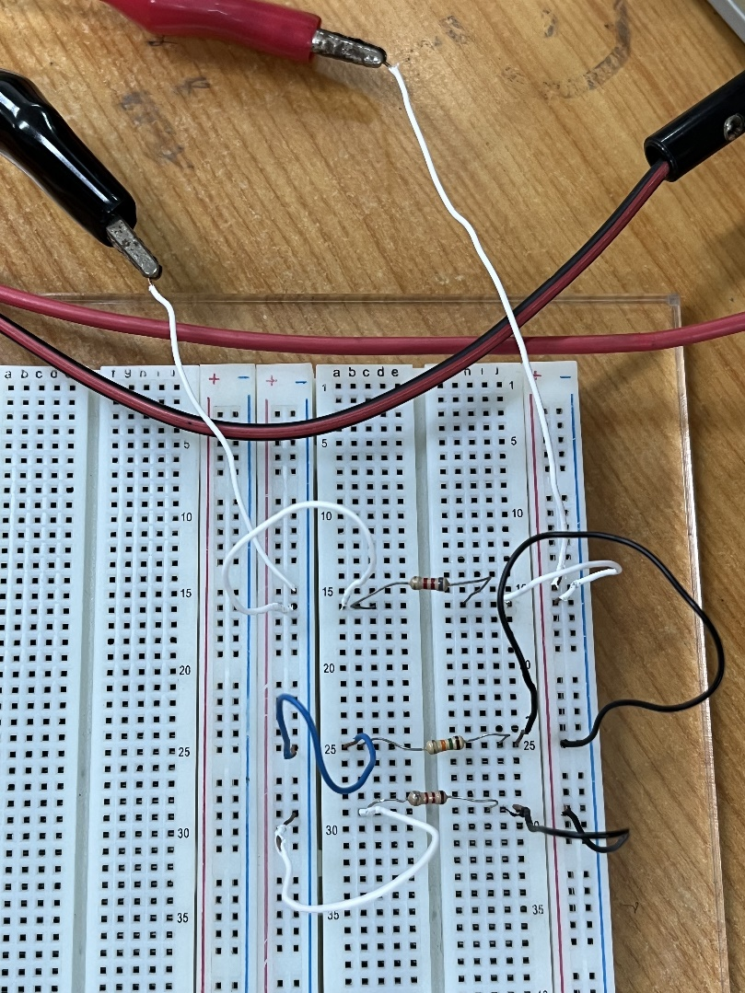

**Figure 2**

**Introduction**

Any circuit needs 3 ports

• Source

• Load

• Wires

**Layout of a Breadboard**

Breadboards are an essential tool for researchers, students, and electrical engineers in a lab setting. They are essential for quick circuit design, experimentation, and prototyping.

**1. Rows, Columns, and Tie Points**

• A standard breadboard is typically divided into rows, columns, and tie points

• Rows run horizontally and are usually labeled with numbers

• Columns run vertically and are typically labeled with letters

• Tie points are the holes where components are inserted and connected.

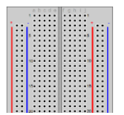

**Figure 3: Breadboard**

**2. Power Buses**

• Breadboards have dedicated power buses, often marked as red (positive) and blue (negative or ground).

• Power buses run alongside the rows and provide power to components.

**3. Distribution Strip**

• Distribution strips run alongside the columns and are connected to the rows.

• They serve as an additional means to distribute power or create common connections.

**Using Breadboards in the Lab**

**1. Component Placement**

• Components are inserted into tie points, ensuring their legs contact the metal clips beneath.

• Proper orientation of components is crucial.

**2. Power Connections**

• Power and ground connections are established by connecting them to the respective power buses on the breadboard.

• Use jumper wires to connect components and create the desired circuits.

**3. Neat and Compact Layout**

• Arrange components in an organized and compact manner to minimize the risk of loose connections and short circuits.

**Some equipment will be used during this laboratory**

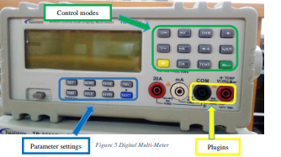

**Figure 4: Multi Meter (DMM)**

* Do not measure the components when they are still attached to the circuit; your measurements will likely be incorrect

**I. Digital Multi Meter (DMM)**

**1. Voltage Measurement**

• Set the DMM's function selector to the voltage (V) setting.

• Ensure the appropriate range is selected (higher than the expected voltage).

• Connect the red test led to the positive side and the black test led to he negative side of the circuit or component.

• Read the voltage measurement from the DMM display.

• Important: When measuring voltage, the DMM should be connected in parallel with the circuit or component, meaning it is connected across the component or points of interest.

**2. Current Measurement**

• Set the DMM's function selector to the current (A) setting

• Ensure the appropriate range is selected (higher than the expected current).

• Connect the DMM in series with the circuit, breaking the circuit path.

• Read the current measurement from the DMM display.

• Important: When measuring current, we get power probe connected to DMM.

**3. Resistance Measurement**

• Set the DMM's function selector to the resistance (Ω) setting.

• Ensure the appropriate range is selected (higher than the expected resistance).

• Connect the test leads to the component or circuit under the test.

• Read the resistance measurement from the DMM display.

(Notice: Do not measure the components when it still attached in the circuit because the results maybe incorrect – isolate the resistor out of the circuit when measure it)

**4. AC Measurements**

• For AC voltage and current measurements, set the DMM to the AC function and select the appropriate range. Follow the same connection procedures as for DC measurements.

• The DMM will provide RMS (Root Mean Square) values.

**5. Continuity Testing**

• Many DMMs have a continuity test function. Set the DMM to continuity mode.

• Touch the test probes to the two points being tested. If a continuous circuit is detected, the DMM will emit an audible beep or display continuity on the screen.

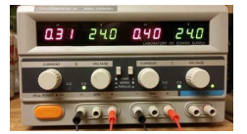

**Figure 5: Power Supply**

To use the Power Supply, there is some steps you must follow it:

• Step 1: Turn on the device and set all the Current and Voltage buttons. (In every section in this course, set the current approximately 0.5A)

• Step 2: Attach the red wire to the Hotwire and black wire to the Ground to supply the power for your circuit.

• Step 3: Set the Voltage button to the required value.

• Step 4: Press the Output button. (If the Light Signal turn RED, check your circuit again, it maybe shorted circuit

**Experimental Procedure**

|  |  |
| --- | --- |
| **A. Reading the Resistors** | |
| 150Ω, 5% =Brown-Green-Brown-Gold  270Ω, 5% =Red-Purple-Brown-Gold  3300Ω, 5% =Orange-Orange-Red-Gold  420Ω, 2% =Yellow-Red-Brown-Red  33KΩ ,5% =Orange-Orange-Orange-Gold  1Ω, 1% =Black-Brown-Black-Brown  1200Ω, 5% =Brown-Red-Red-Gold  220Ω, 1% =Red-Red-Brown-Brown  3900Ω, 2% =Orange-White-Red Red  10KΩ, 5% =Brown-Black-Orange-Gold | 56KΩ, 5% =Green-Blue-Orange-Gold  1KΩ, 5% =Black-Brown-Orange-Gold  1MΩ, 5% =Black-Brown-Blue-Gold  100000Ω, 5% =Brown-Black-Yellow-Gold  390Ω, 5% =Orange-White-Brown-Gold  3300 Ω, 5% =Orange-Orange-Red-Gold  330KΩ, 2% =Orange-Orange-Yellow-Red  47Ω, 5% =Yellow-Purple-Black-Gold  10KΩ, 5% =Brown-Black-Orange-Gold  1500Ω, 2% =Brown-Green-Red-Red |
| **B. Measure the Resistor values** | |
| Orange-grey-green 38k (actual value =38.26k)  Brown-green-green 15k (actual value = 14.8k)  Grey-red-red 8.2k (actual value = 8.204k)  Grey-black-red 8k (actual value =8.1k)  Orange-Orange-Orange 33k (actual value = 33.2k) | |

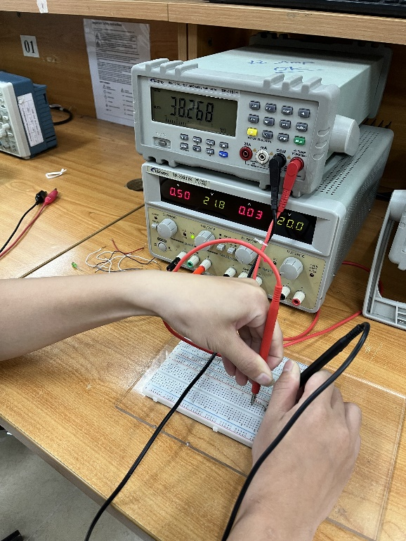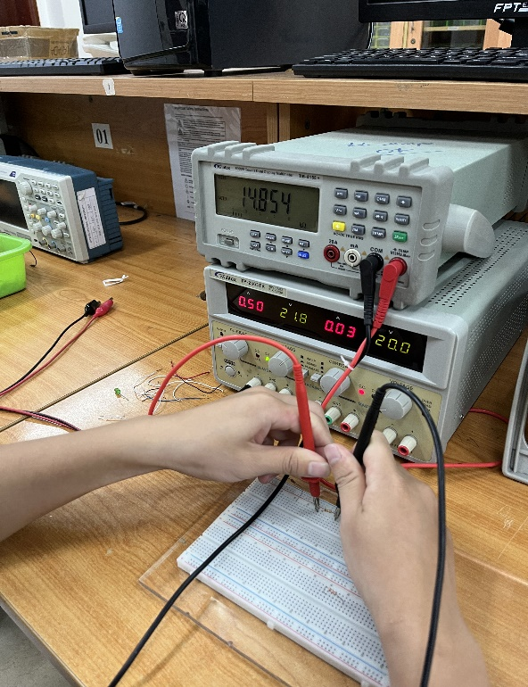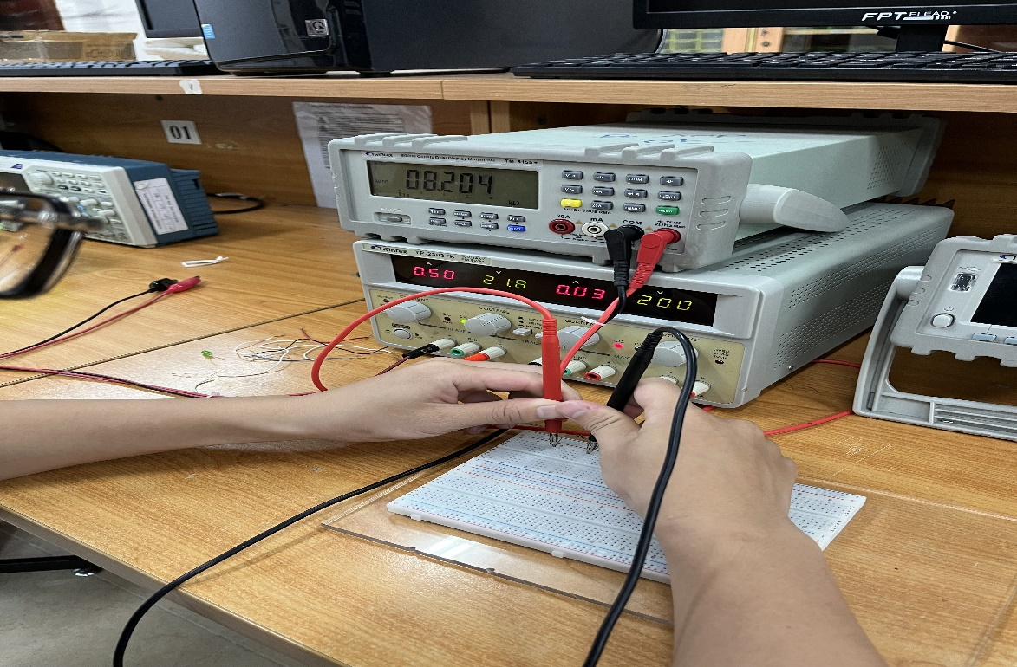

**Figure 6**

**Experimental Results**

• Prior to establishing a connection between the circuit and the power source, it is imperative to meticulously set the voltage output precisely to 5V and finely adjust the current to a controlled 0.5A.

• This meticulous calibration serves as a prudent safety measure, effectively mitigating the risk of any inadvertent short-circuit occurrences. Raising the voltage beyond this specified threshold could potentially impose an excessive load on the resistor, resulting in the undesirable consequence of electronic devices incineration and possible damage.

**Power Supply**

• An overload condition is indicated when the machine's indication changes from constant voltage (C.V.) to constant current (C.C.). The current surges significantly at this phase, requiring an instant shutdown.

**Digital Multi-Meter (DMM)**

• It is best to take the resistor out of the circuit and put a single probe into it while putting the second probe into any other part of the circuit in order to measure resistance.

• It is advised against taking direct measurements of current at the machine's mA level since doing so could cause the internal fuse to be damaged. Specifically, this fuse acts as a protection for the device, which breaks when exposed to high current levels.

**Discussion of Results**

• It can be determined that using a Digital Multi-Meter (DMM) to measure resistor values is linked to an error margin that falls between 5 and 10% when compared to Ohm's Law and the actual test findings.

• We learned how fuses operate and how to determine whether a fuse is still operational during this lab session.

=> Use a multimeter to complete this operation by turning the selector knob to mode of measurement for continuity. A probe should be placed on one end of the fuse and another on the other. The DMM's operational condition is intact if it beeps, which signifies that the fuse is open. This result confirms that there are no broken connections inside the fuse.